Objective:
Use Subqueries, CTEs, and Window Functions to analyze sales data from the Superstore dataset.
Tasks
Step 1: Setup Data
- Import the Superstore dataset into a table named superstore_raw.
- Create these 3 tables from it:
- customers
- orders
- products
- Insert data into these tables using SELECT DISTINCT.
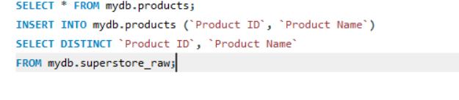

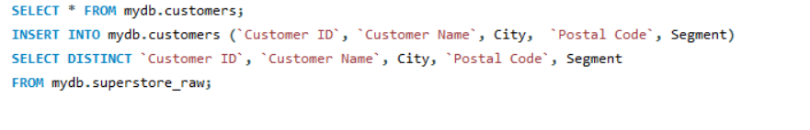

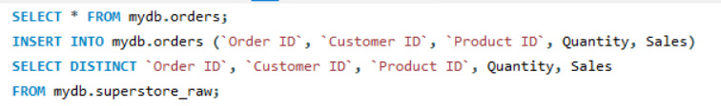

Step 2: Perform Required Queries
Write and execute SQL queries for each of the following:
- Find all orders where sales are greater than the average sales. (Subquery)
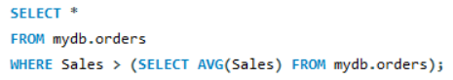

- Find the highest sales order for each customer. (Subquery)

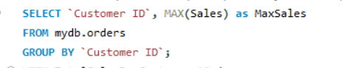

- Calculate total sales for each customer. (CTE)
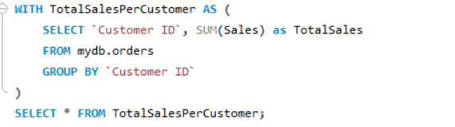

- Find customers whose total sales are above average. (CTE + Subquery)
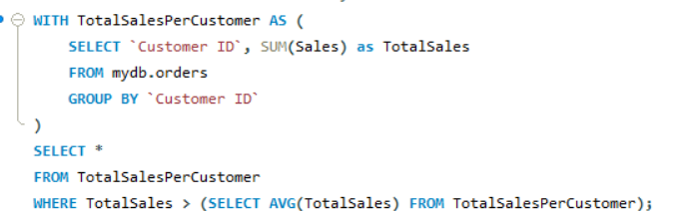

- Rank all customers based on total sales. (Window Function)
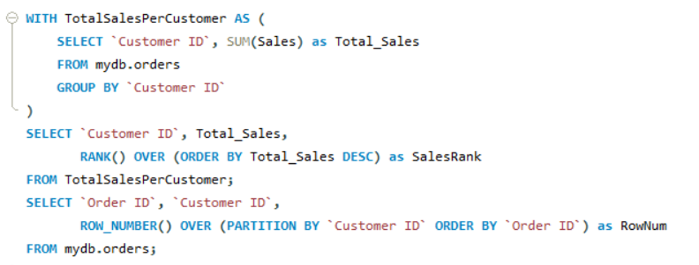

- Assign row numbers to each order within a customer. (Window Function + PARTITION BY)

- Display top 3 customers based on total sales. (Window Function)
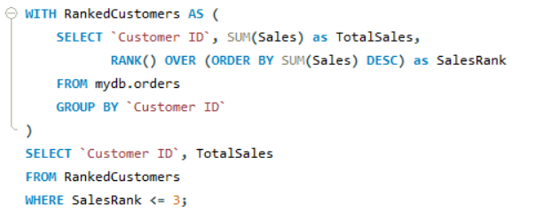

Step 3: Final Combined Query
Write one final query that shows:
- Customer Name
- Total Sales
- Rank
(Use JOIN + CTE + Window Function together)

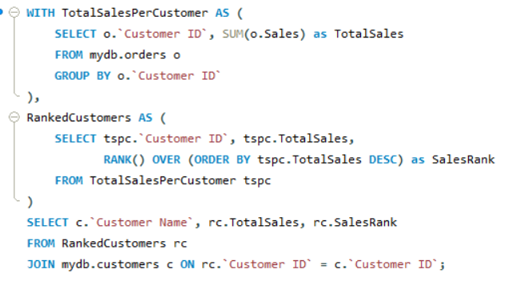

Mini Project: Customer Sales Insights
Answer the following using SQL:
- Who are the top 5 customers?
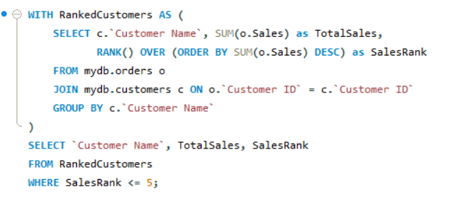

- Who are the bottom 5 customers?
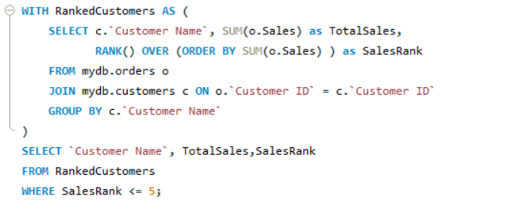

- Which customers made only one order?
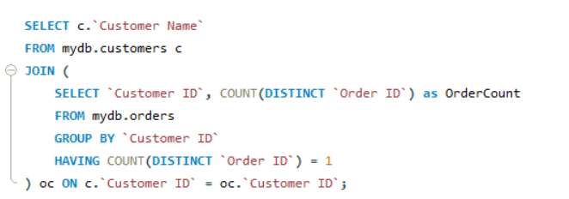

- Which customers have above-average sales?
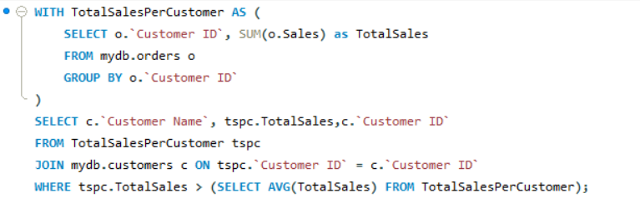

- What is the highest order value per customer?
